**SOFTWARE INSTALLATION PLAN**

|  |  |  |  |  |  |  |  |  |  |  |
| --- | --- | --- | --- | --- | --- | --- | --- | --- | --- | --- |
| **NAME OF WORKSTATION:** | | | | PC-USER5 | | | **Prepared by:** | Gabriel Ezekiel-Hart | | |
| **DATE:** | 02-09-2021 | | | | | | **LOCATION**: | IT Workshop | | |
|  | | | | | | **DATE OF INSTALLATION** | | | 02-09-2021 | |
|  | | | | | | | | | | |
| **Start time:** | | 2:06 PM | | | | **Expected time of completion:** | | | | 2:11 PM |
|  | | | | | | **Actual time of completion:** | | | | 2:15 PM |
| Required resources: | | | Disk, CDs, File location, Registration details, Product key | | | | | | | |
| Location of required resources | | | Network pool ( | | | | | | | |
|  | | | | | | | | | | |
| **Sequence of Activities** | | | | | | | | | | |
| Confirm details with customer  Check compatibility with the system  Minimum system requirements  Create a backup  Check the configuration of the system  Carry out the installation  Record details ( version, product key, installation date & time and configuration details)  Test the software  Demonstrate the software | | | | | | | | | | |
| **Actions to be Performed** | | | | | | | | | | |
| Minimum system requirements | | | | | | | | | | |
| **Software to determine** | | | | | **Hardware** | | | **software** | | |
| Windows 8 pro | | | | | * 1Ghz or faster 32-bit (x86) or 64-bit (x64) processor * 1GB RAM (32-bit) or 2GB RAM (64-bit) * 16GB available HDD (32-bit) or 20GB (x64-bit) * DirectX 9 graphics with WDDM 1.0 or Higher driver | | | NIL | | |
| **Sequence of Activities** | | | | | **Description** | | | | | |
| Backup and create a restore point | | | | | Backup system files prior to the installation | | | | | |
| Delete unwanted files/ software | | | | | Delete the window.old folder if found | | | | | |
|  | | | | | **Installed software details** | | |  | | |
| **Software to be installed** | | | | | **Version No** | | | **Media type** | | |
| Windows 8 Pro | | | | | 6.2.9200 Build 9200 | | | .ISO | | |
| **Configuration details entered during the installation** | | | | | | | | | | |
| Computer name | | | | | Gabby | | | | | |
| Computer/network settings | | | | | Use express settings | | | | | |
| Username | | | | | PC-USER5 | | | | | |

**TEST CHARTS**

|  |  |  |
| --- | --- | --- |
| S/N | TEST | REMARK |
| 1 | Check that OS boots without errors |  |
| 2 | Check for non-functional driver in the device manager |  |

Firefox deployment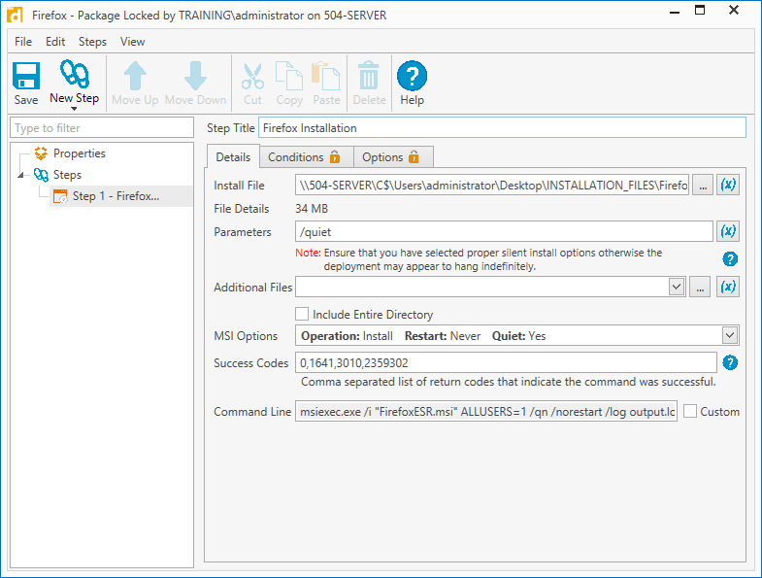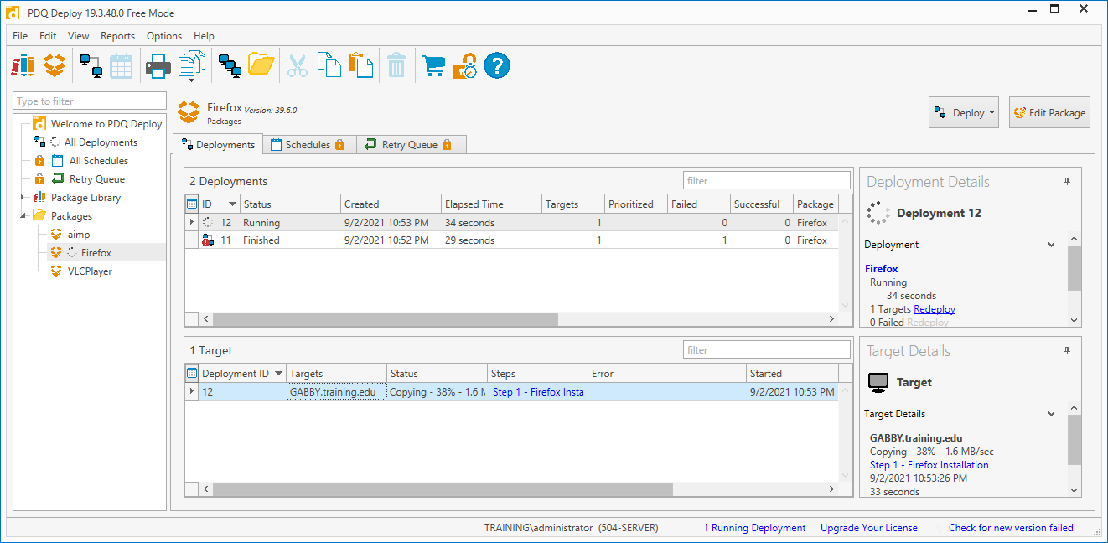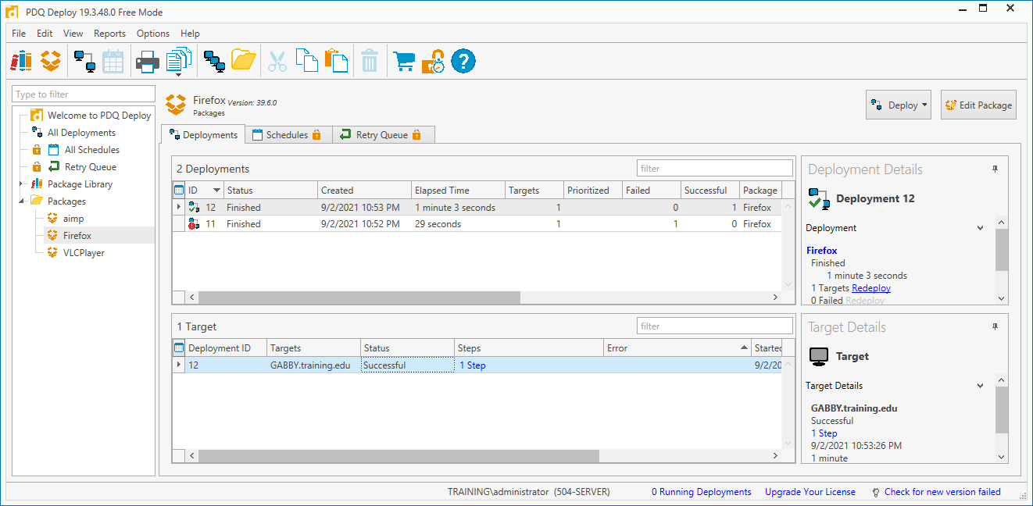

VLC deployment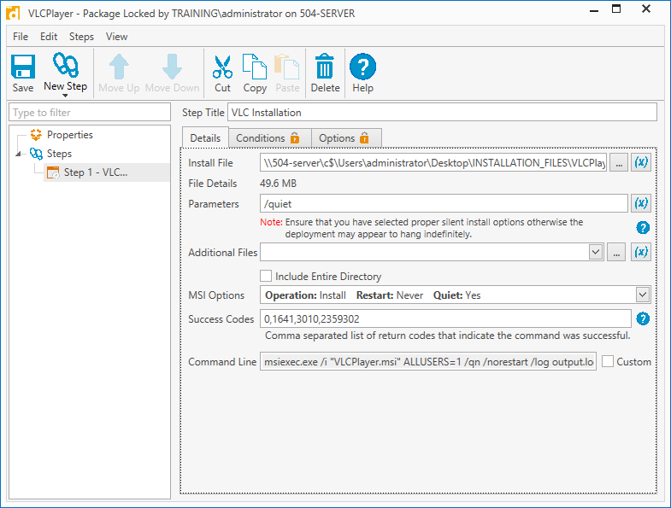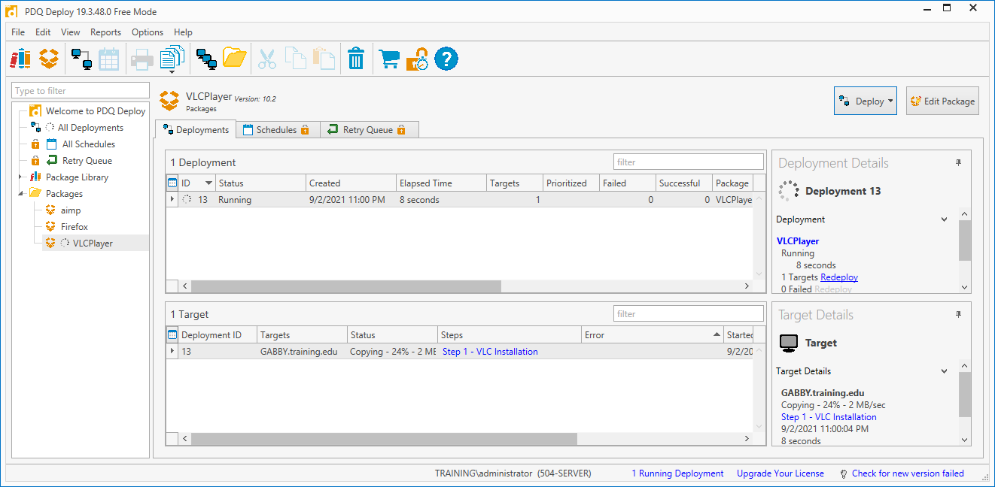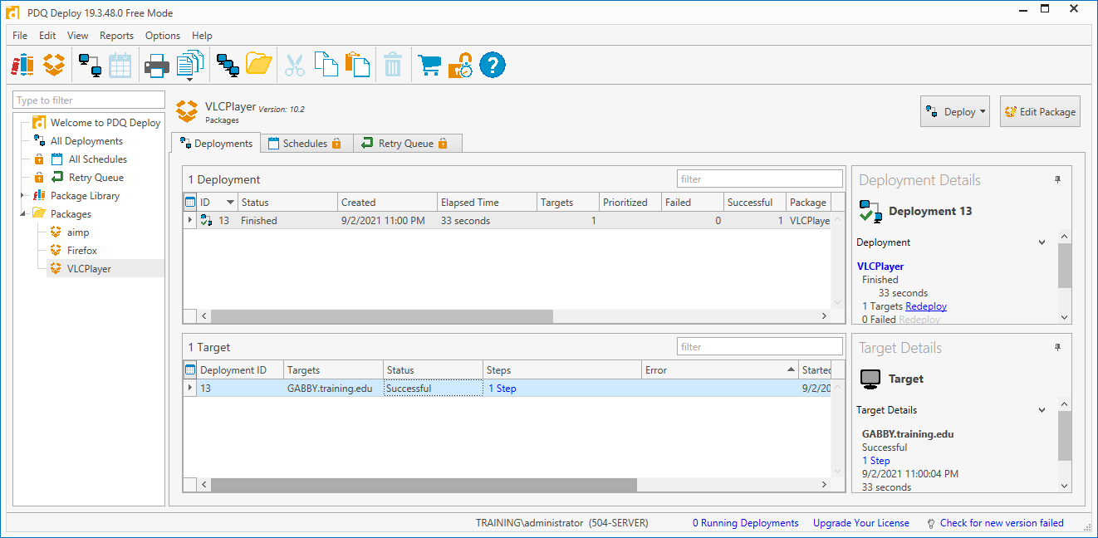

**ITOP Deployment**